Bootcamp - Case Study

## Pre-requisites

Forked the code from Github repository

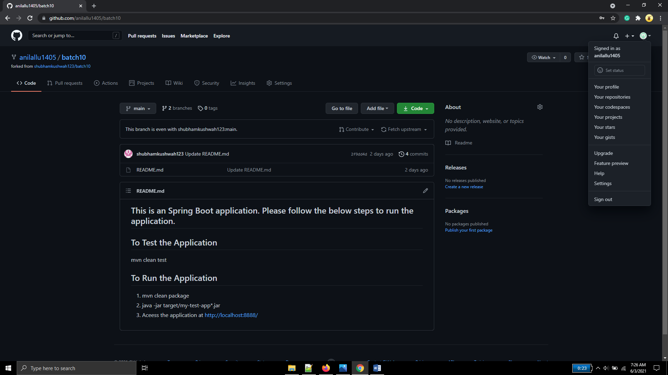

Installed Jenkins in master node GCP instance

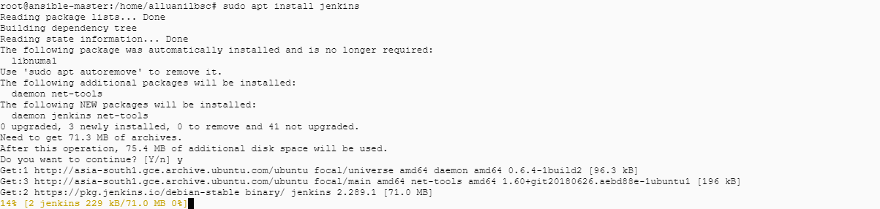

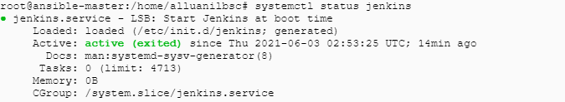

Installed the plugins - Ansible, Docker, Build Pipeline, Html Publisher plugin 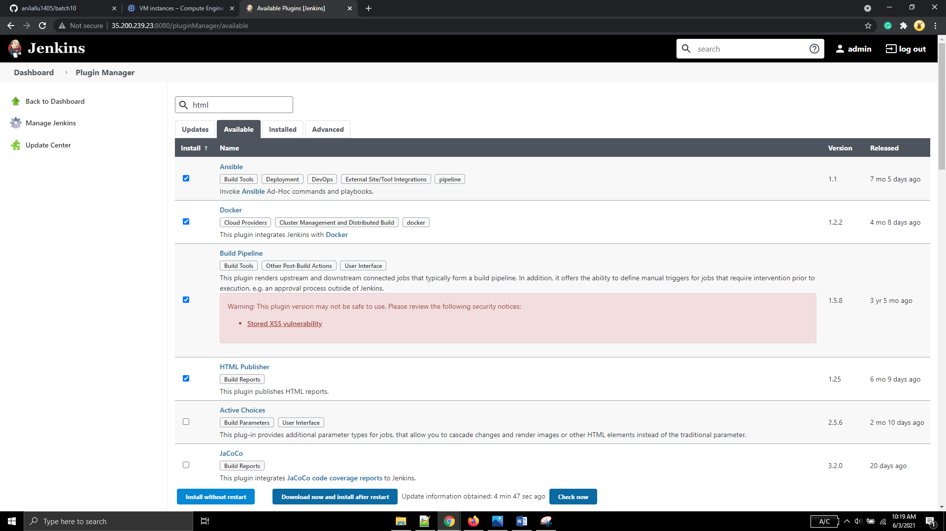

Junit, Credentials plugins are already pre-installed

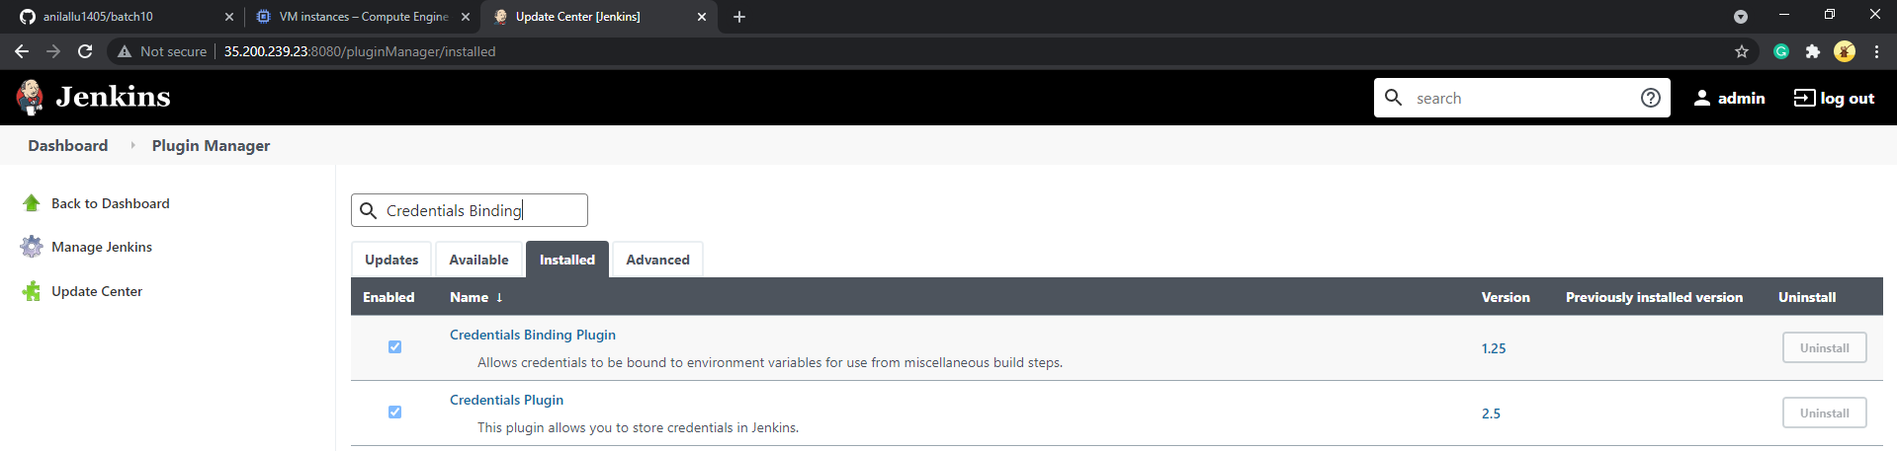

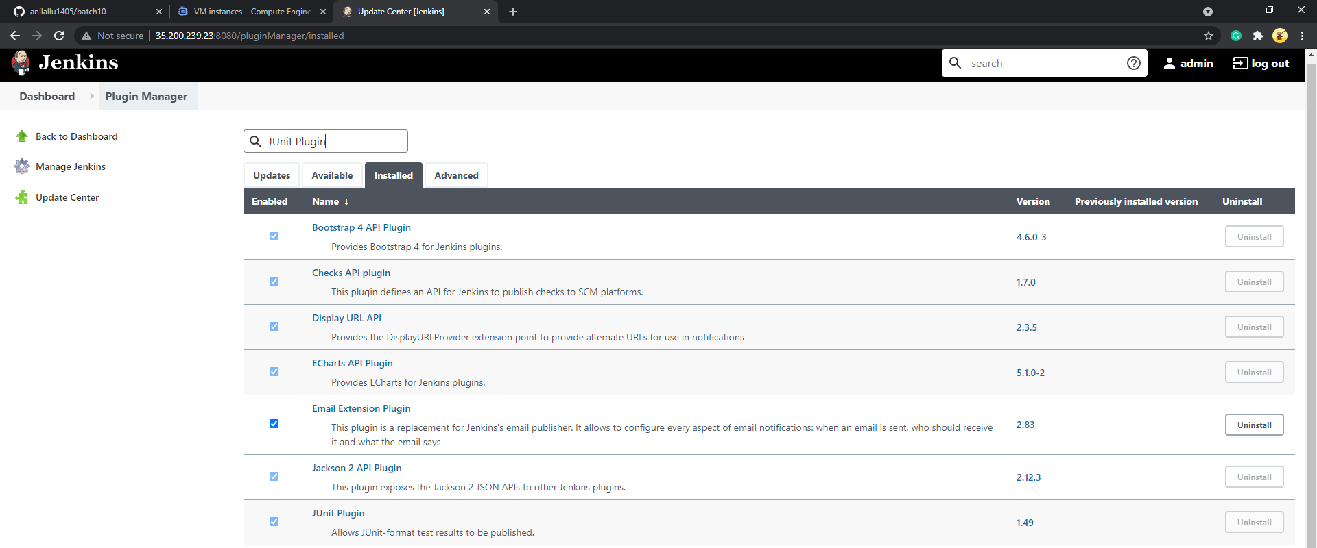

Global Tool Configuration(for maven, ansible, docker):

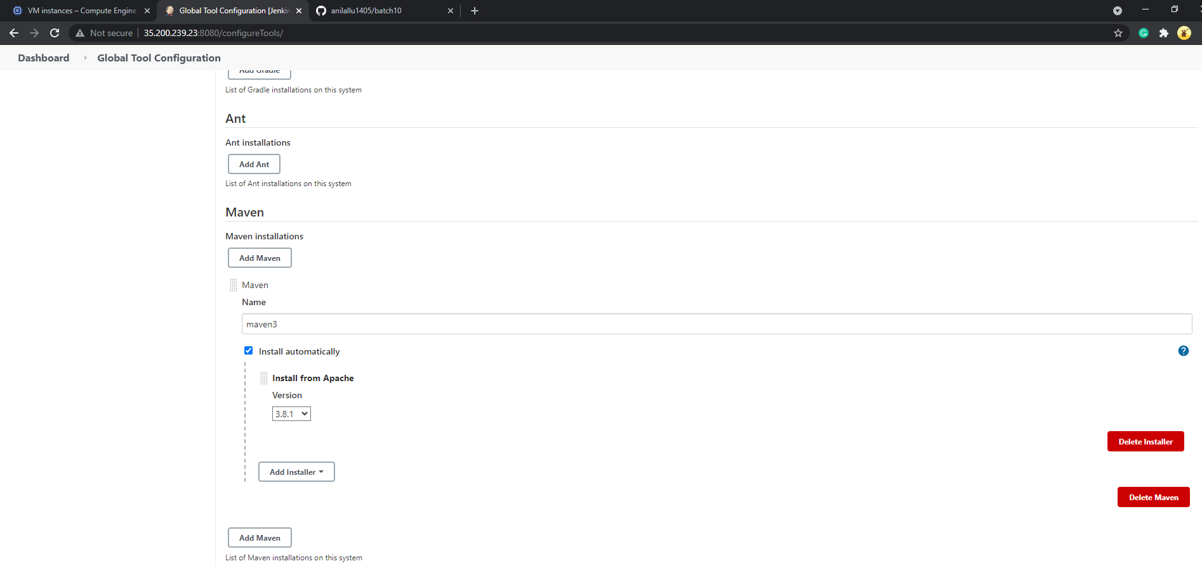

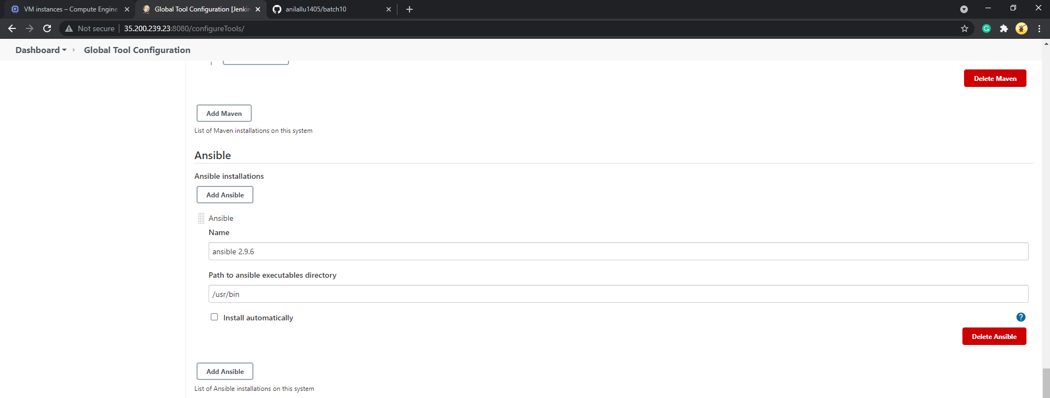

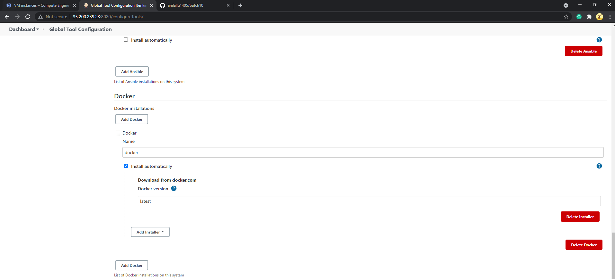

Configured email details

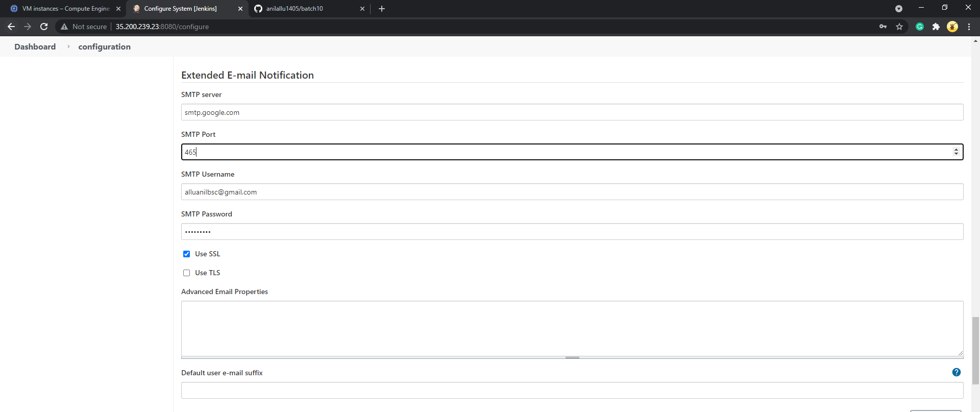

Faced authentication and timeout errors after configuring email.

After resolving email plugin errors using this [link](https://stackoverflow.com/questions/39417636/javax-mail-authenticationfailedexception-534-5-7-14-https-accounts-google-co/39452147), test email got successful

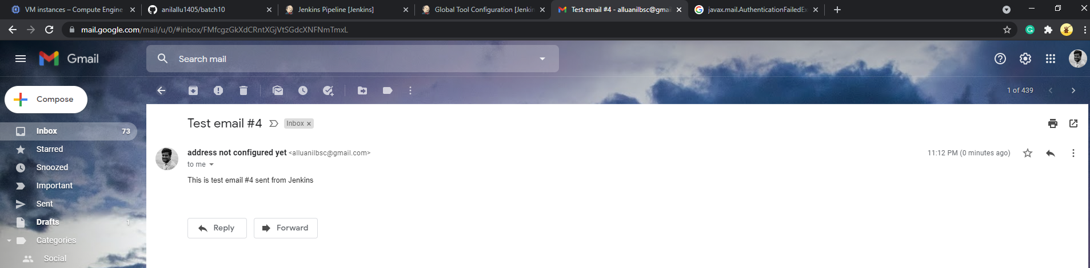

## Code checkout from Git repository

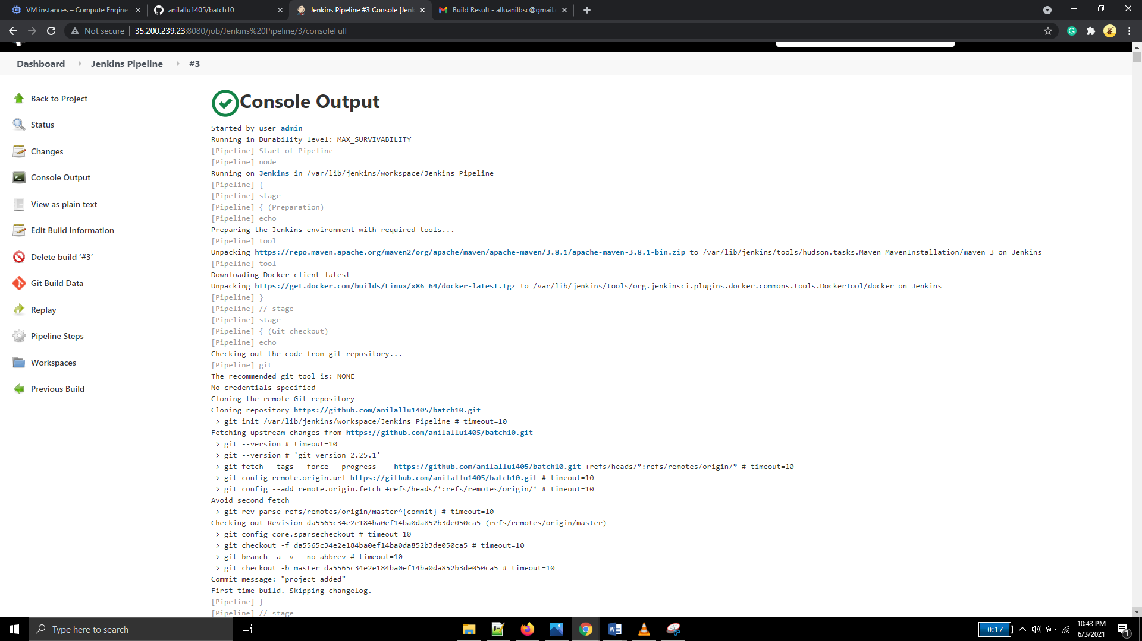

## Build, Test and Package using Jenkins runtime provided Maven

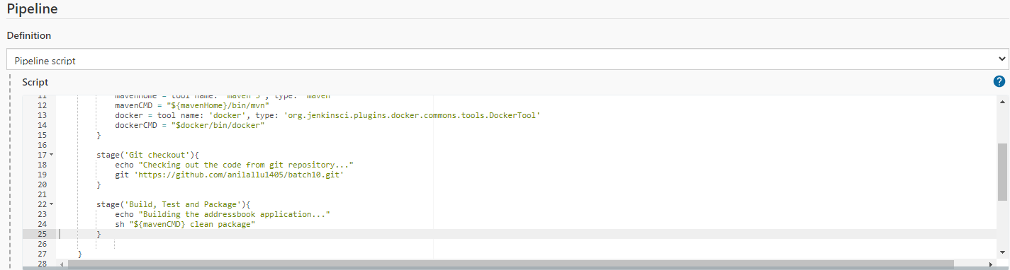

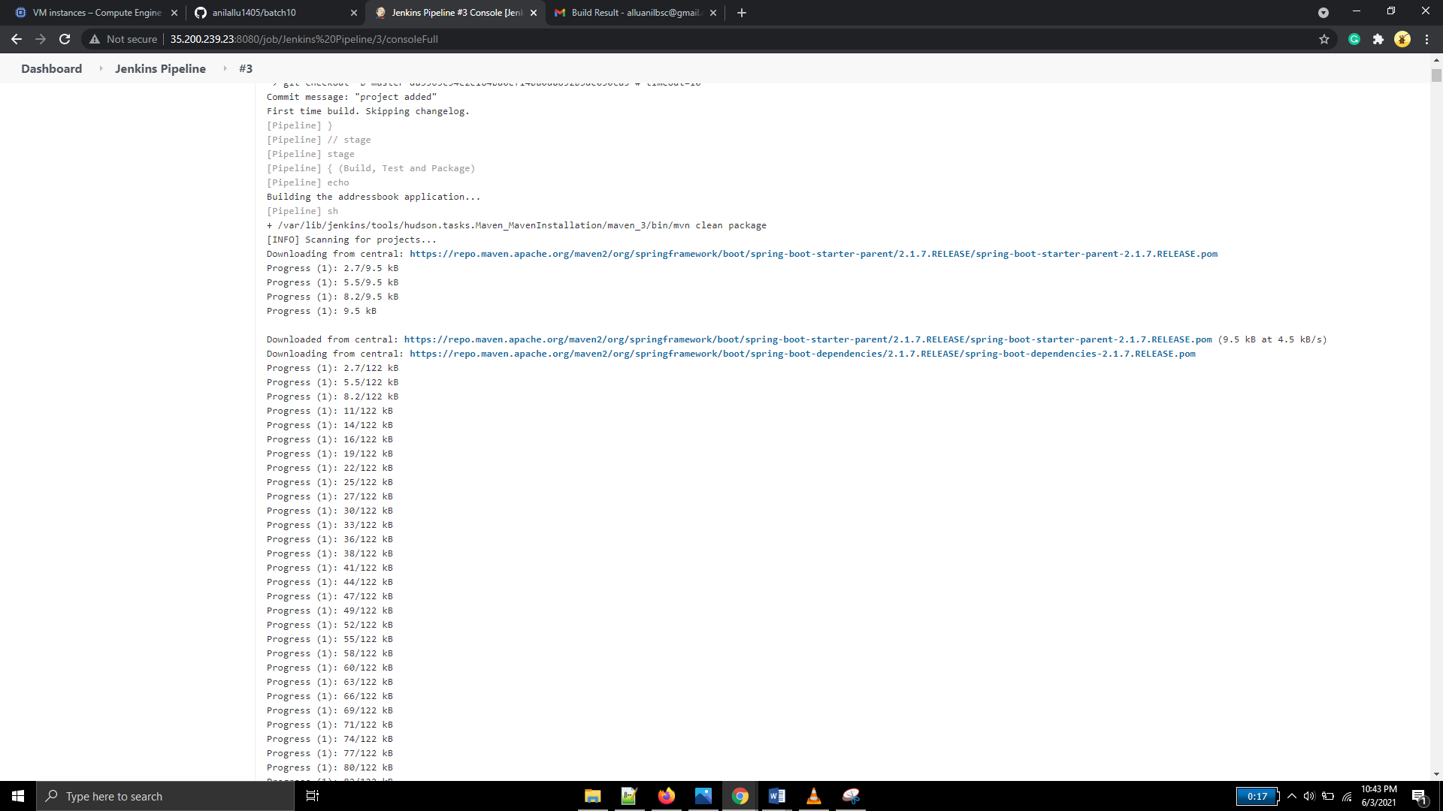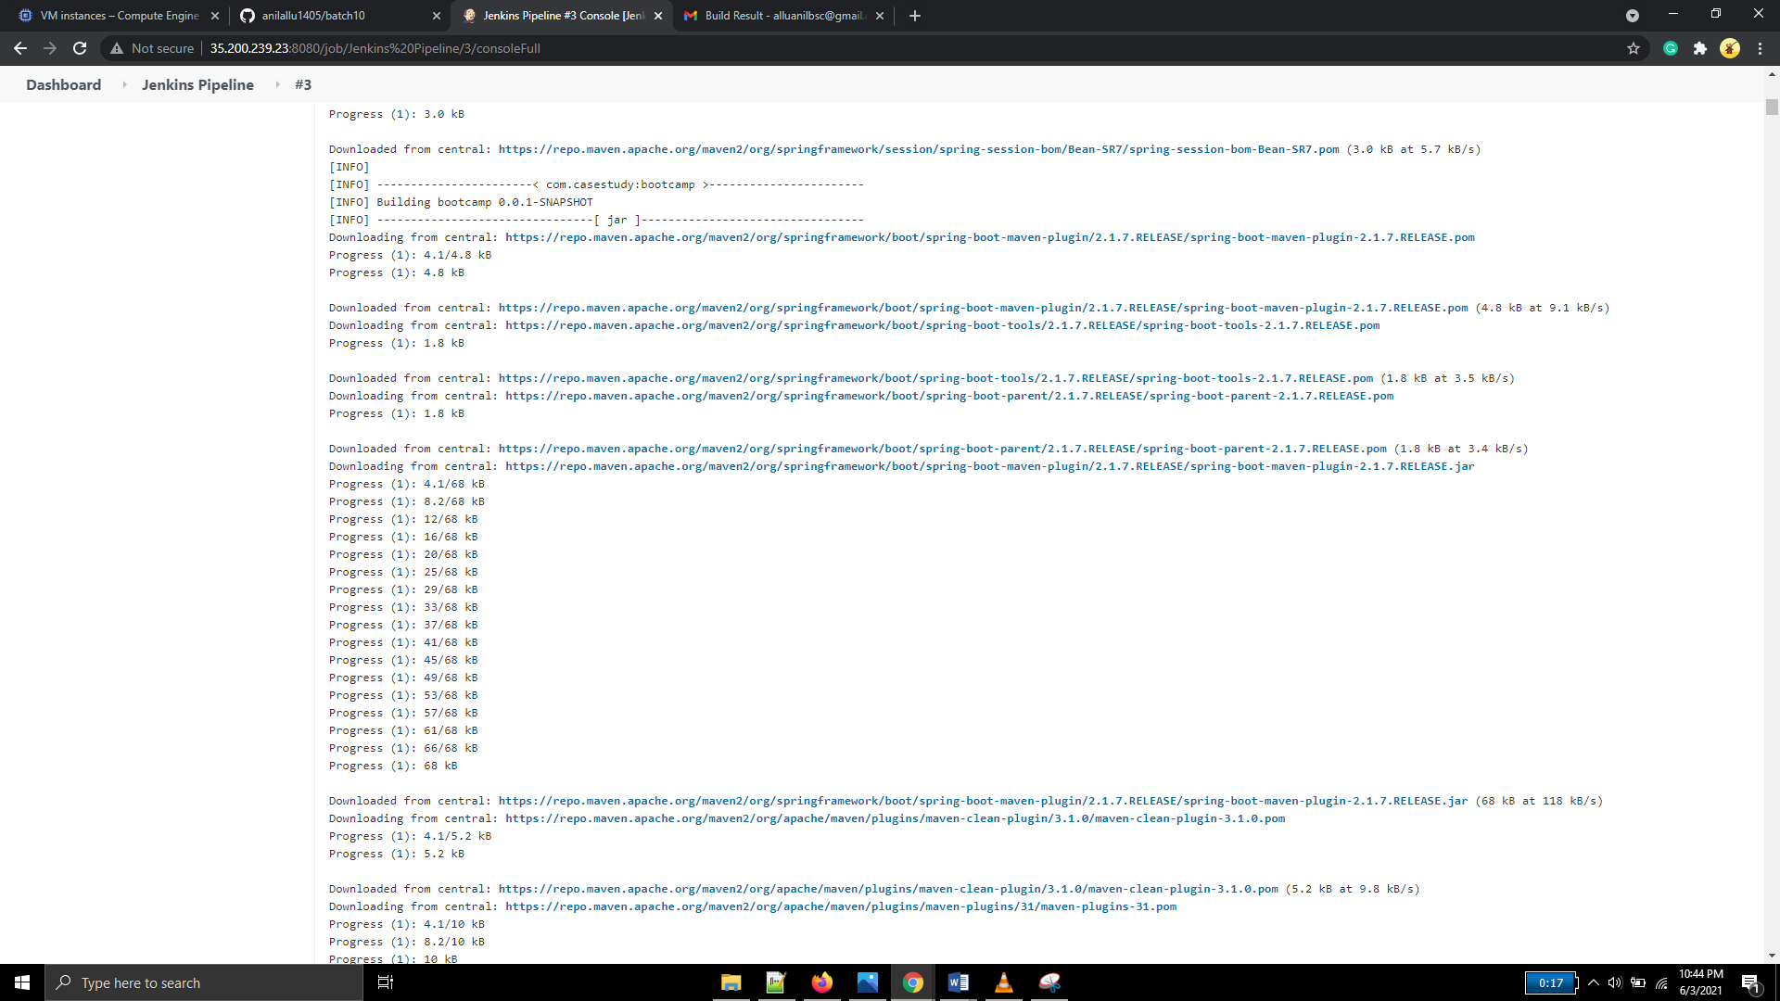

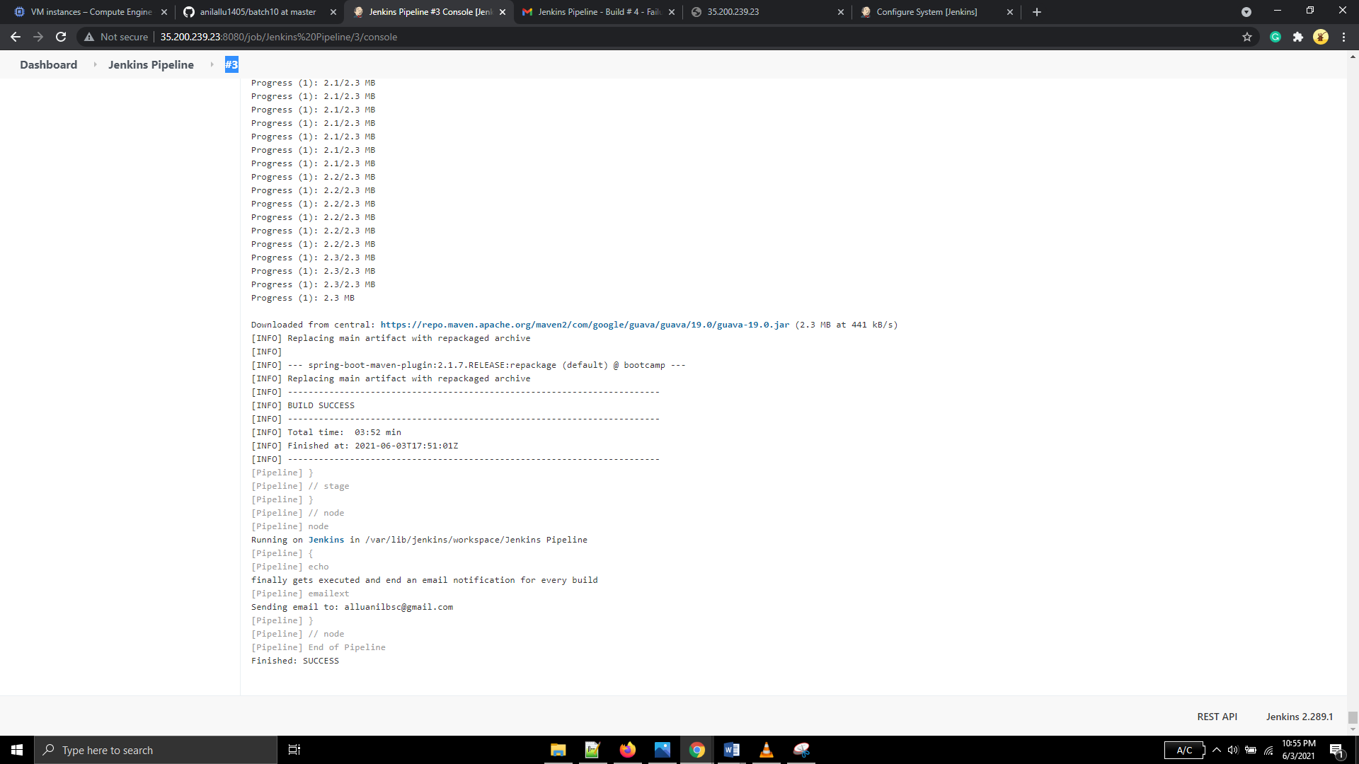

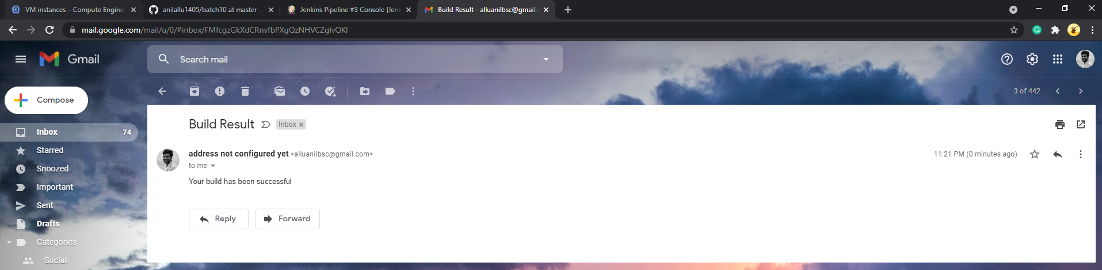

Package created but deployment of jar file failed(in build #4) due to incorrect jar file name.

Correct the jar file name with *.jar under target directory and ran build #5

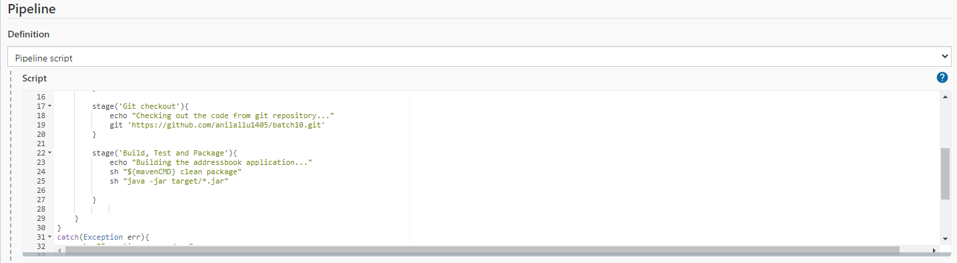

Job log:

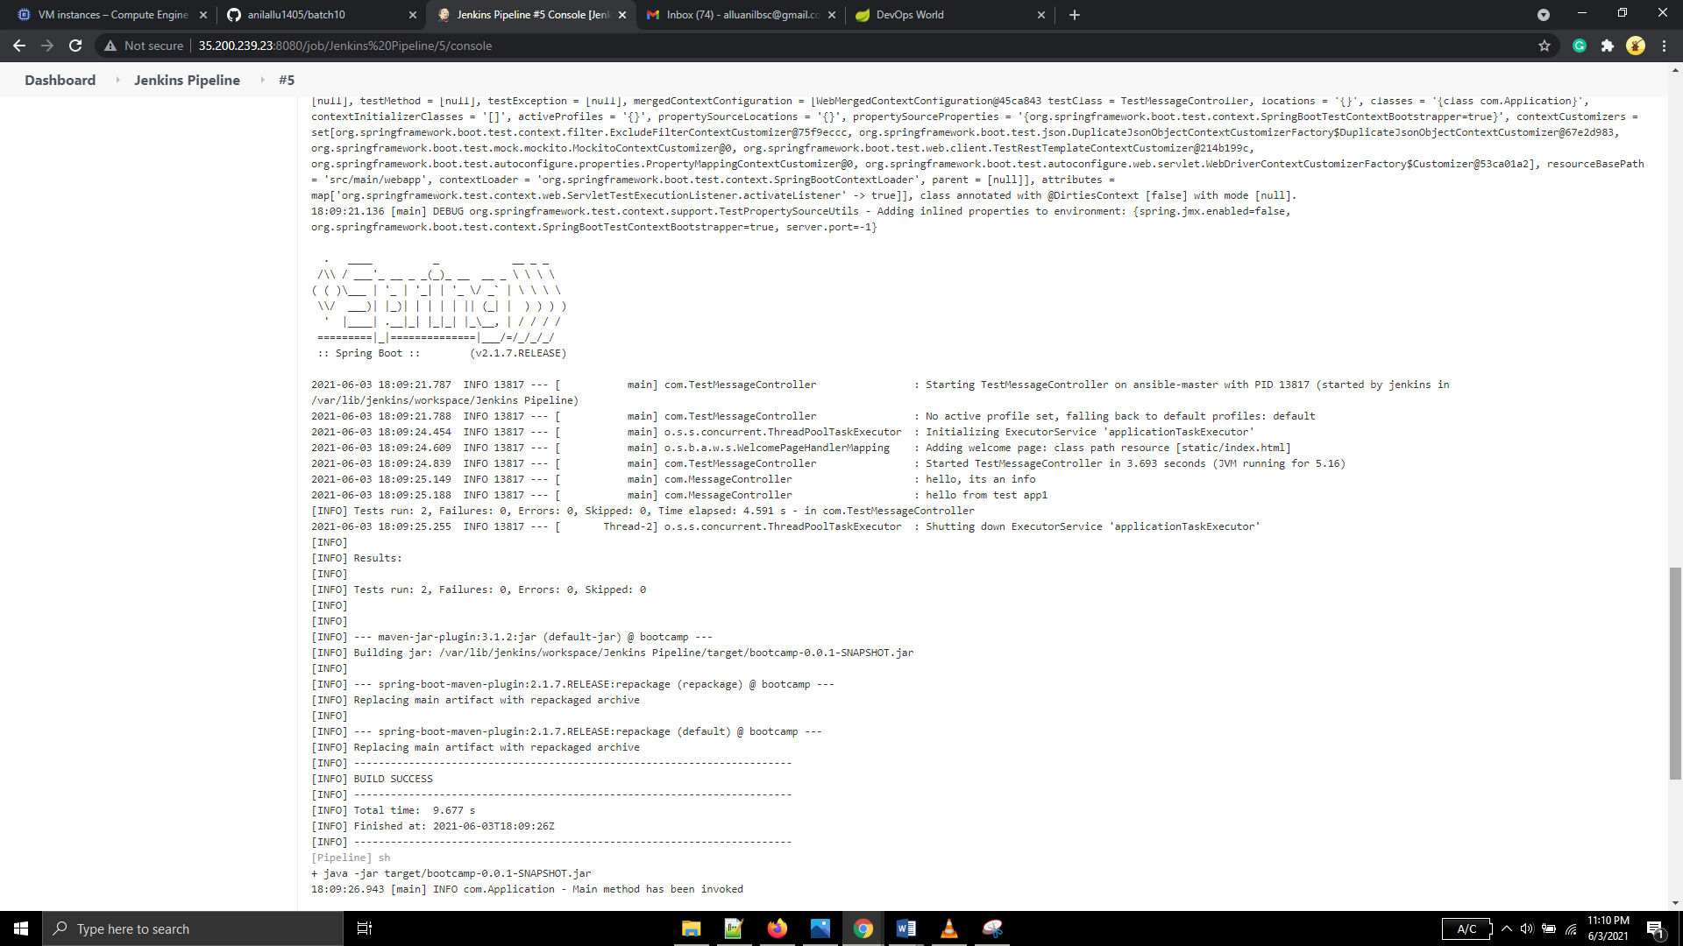

## SonarQube implementation

Installed Plugin

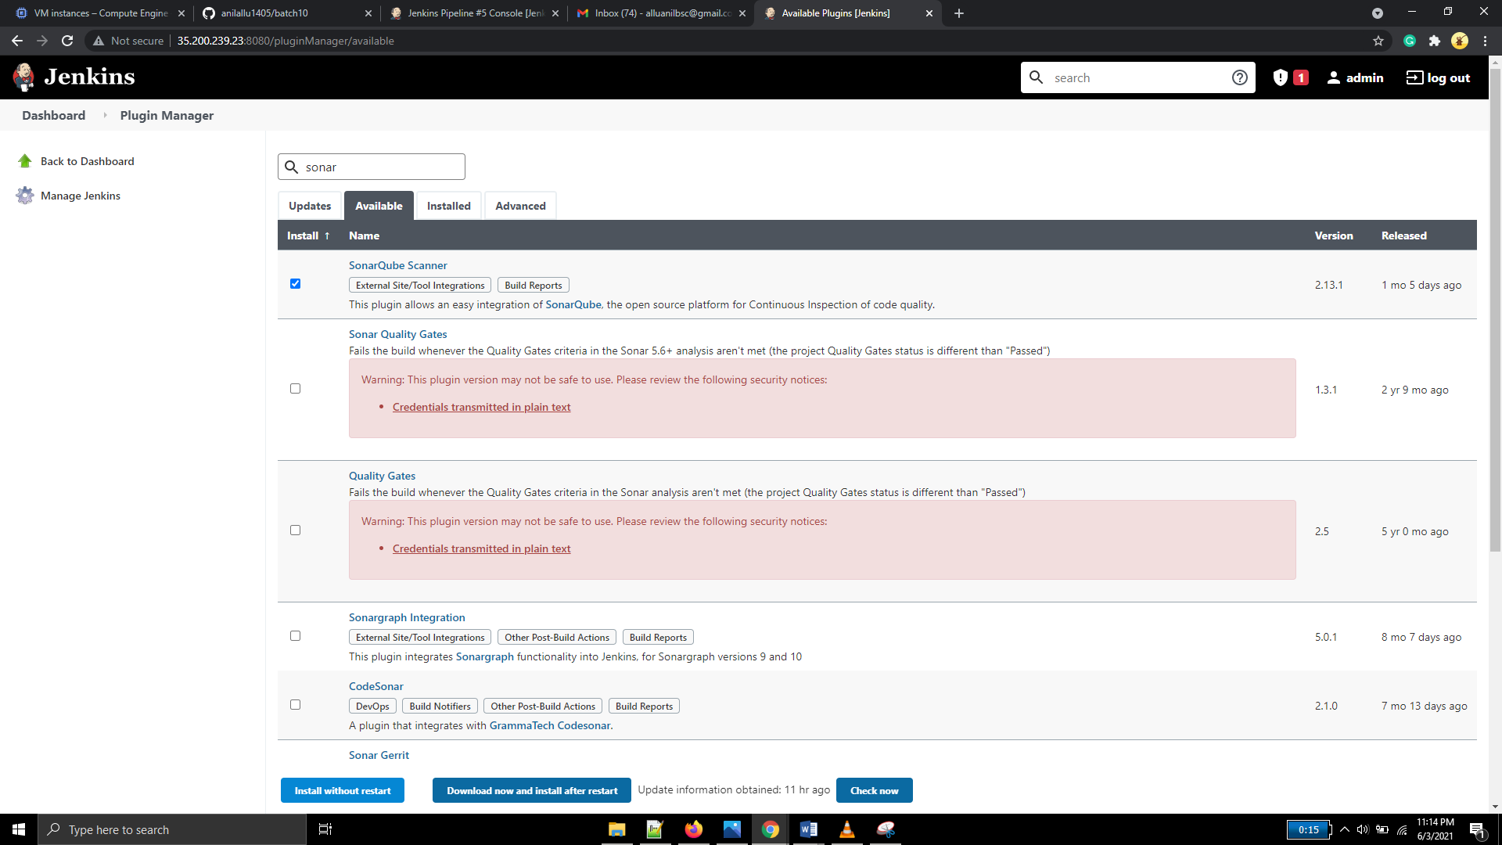

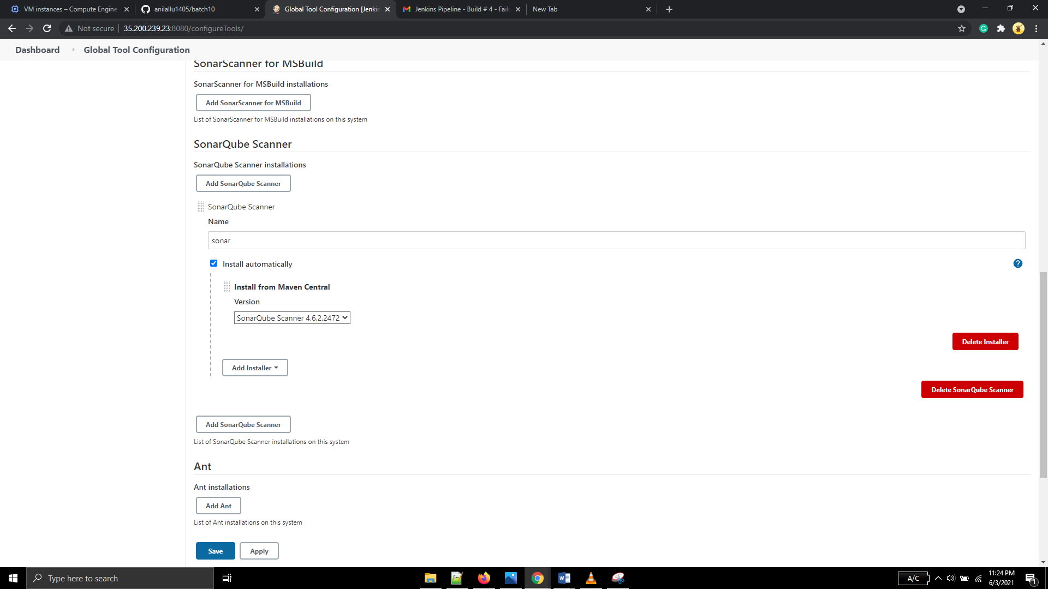

Unable to run sonar scanner, installed SonarQube in the GCP instance.

SonarQube is running but curl command(the sonarqube url) is not working

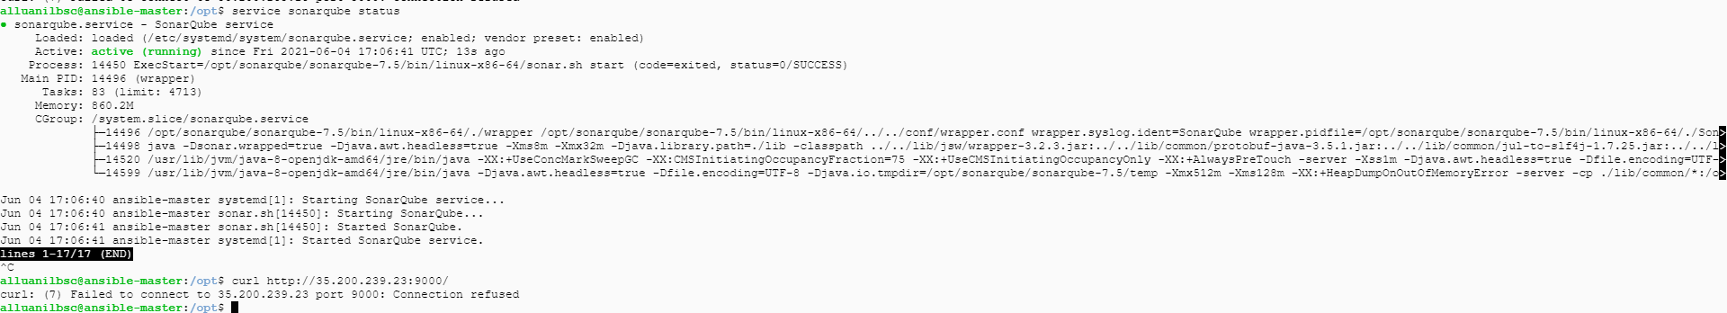

Skipped to next step, keeping this aside and tried at the last (during build#26)

Installed SonarQube in another vm as docker image

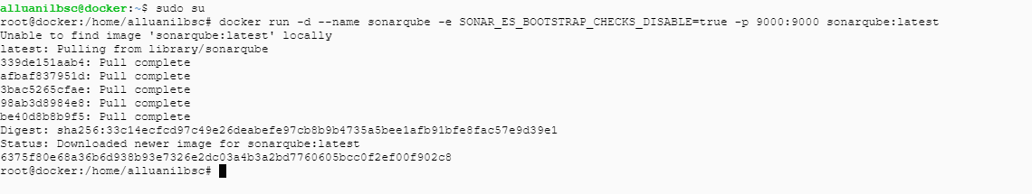

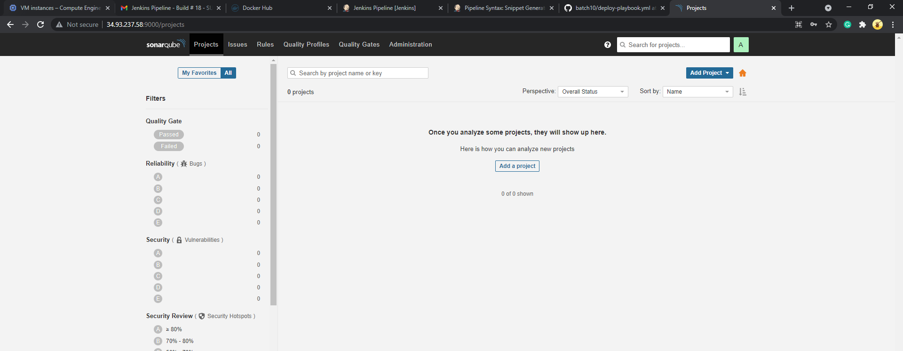

Generated an authentication token and configured in jenkins

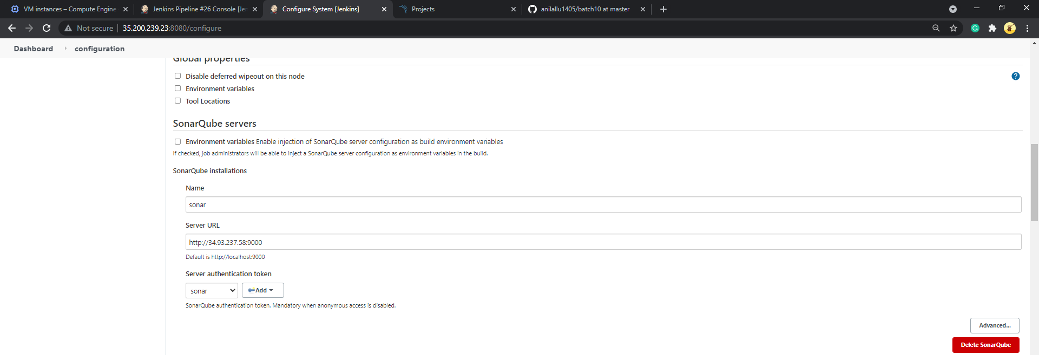

Triggered build(build #26) and it ran successfully

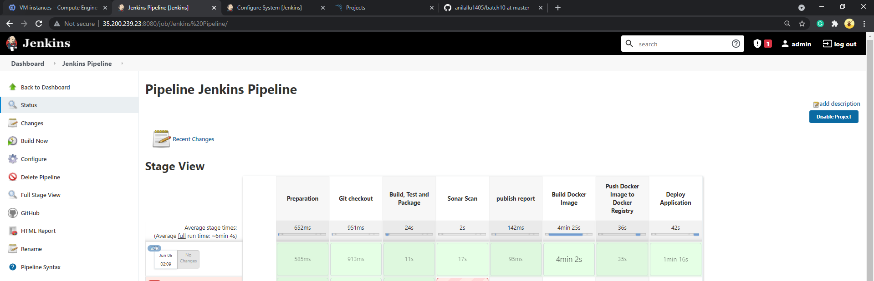

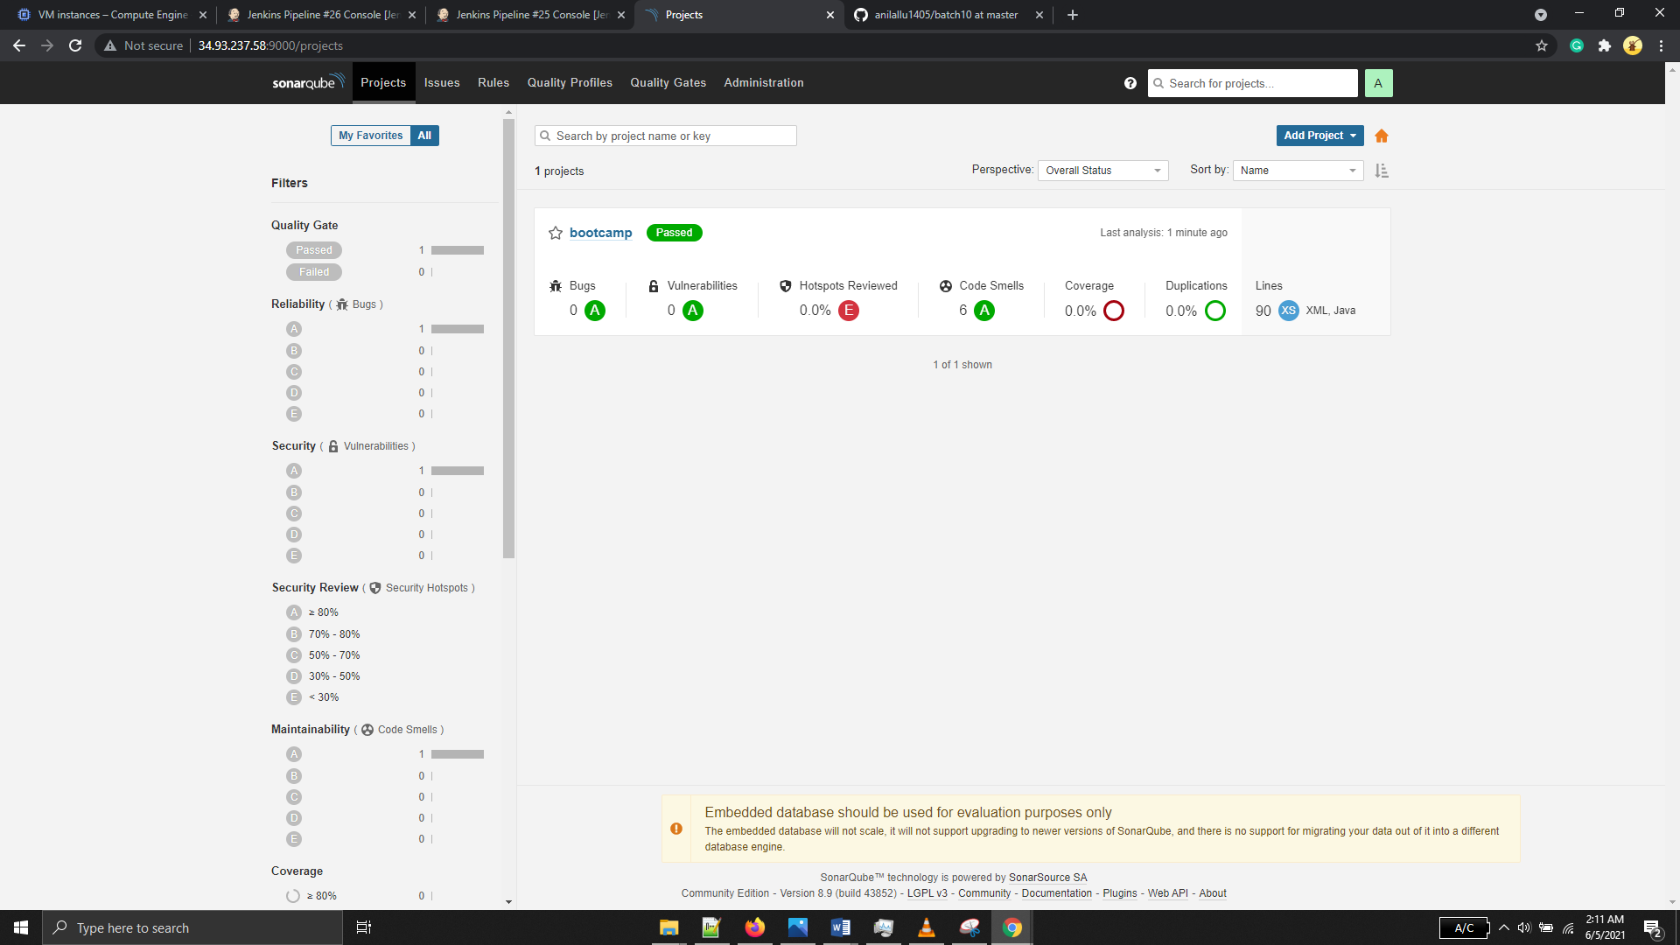

Full report:

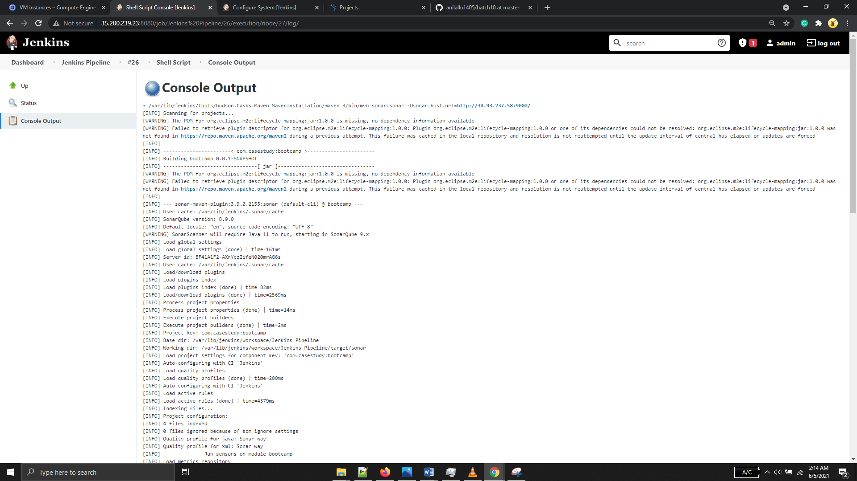

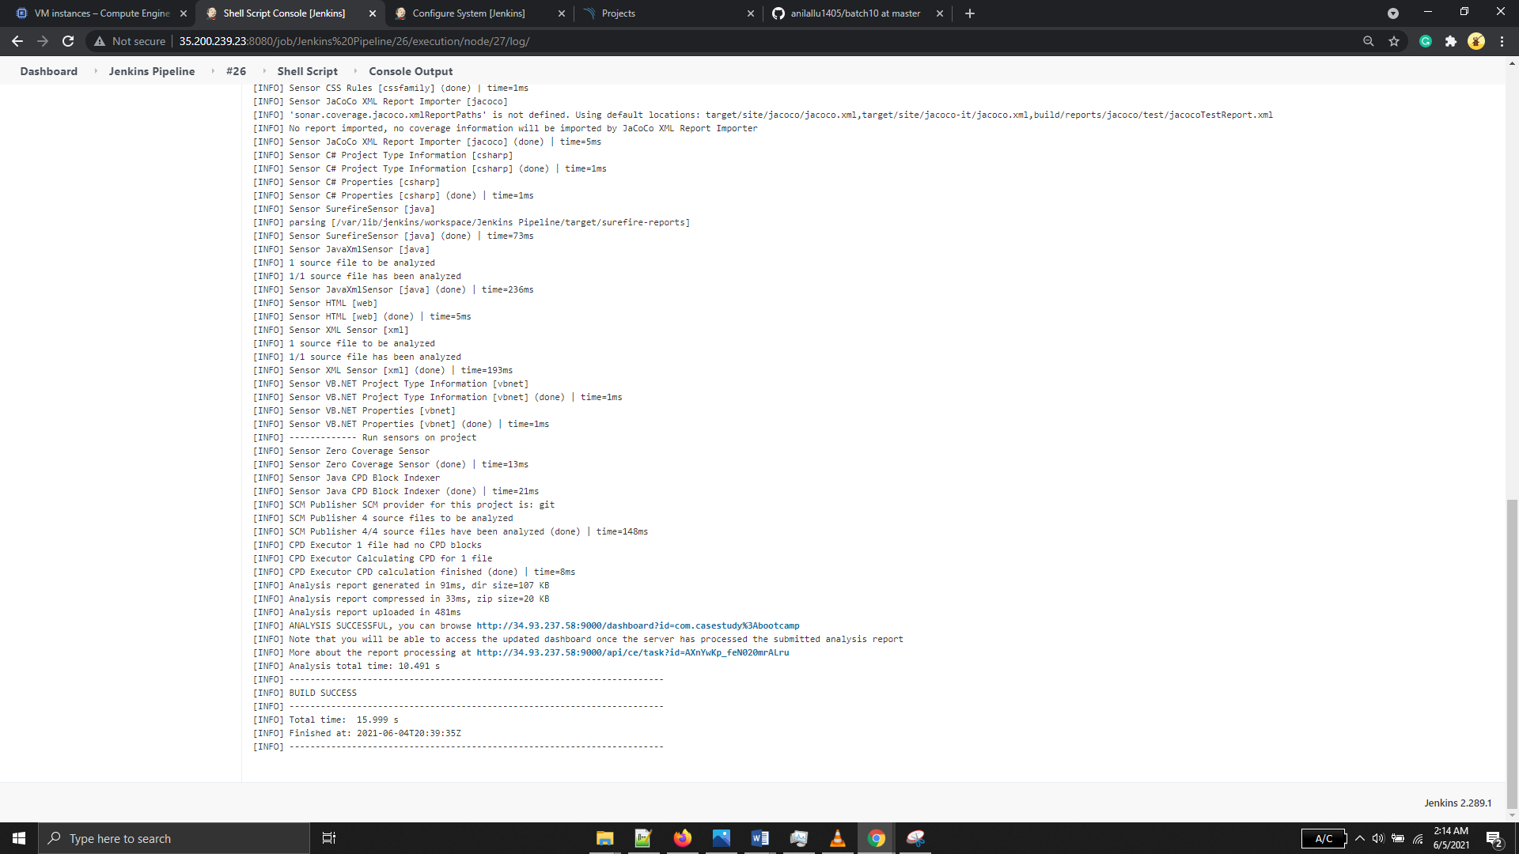

## HTML reports for Junit test cases

Added the code to publish reports (Build #11). Build ran successfully

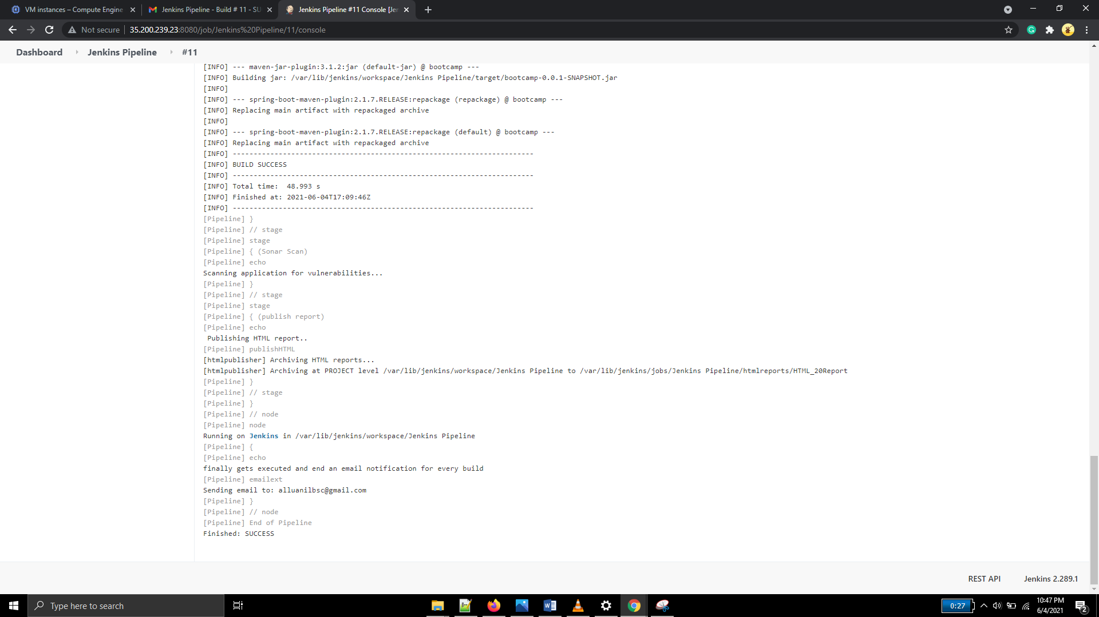

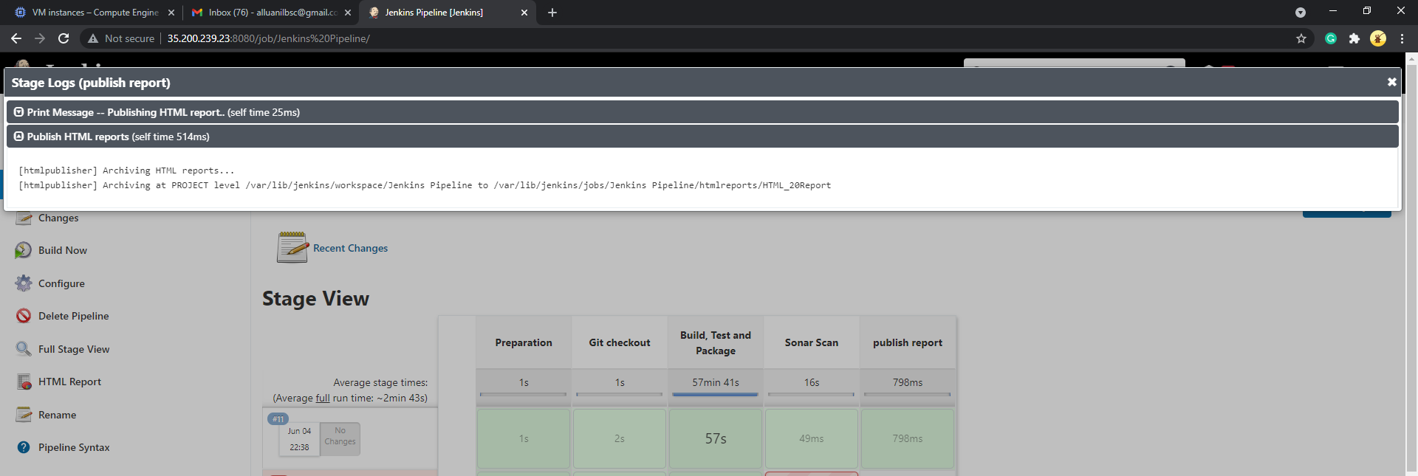

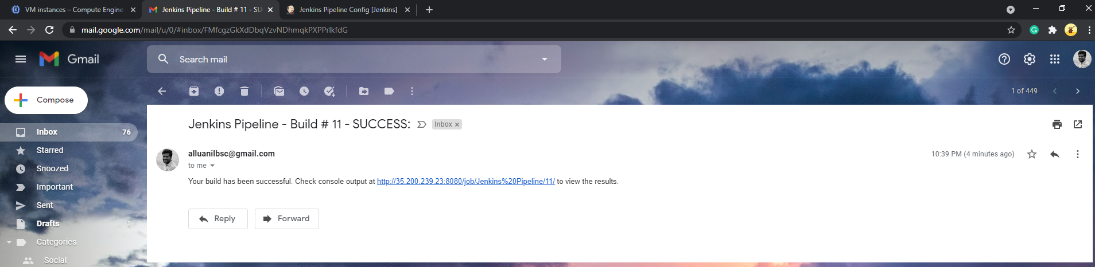

## Dockerfile to create image for each application

Created a dockerfile under the path /var/lib/jenkins/workspace/Jenkins\ Pipeline

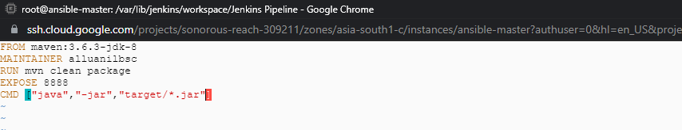

Job aborted due to permission issue

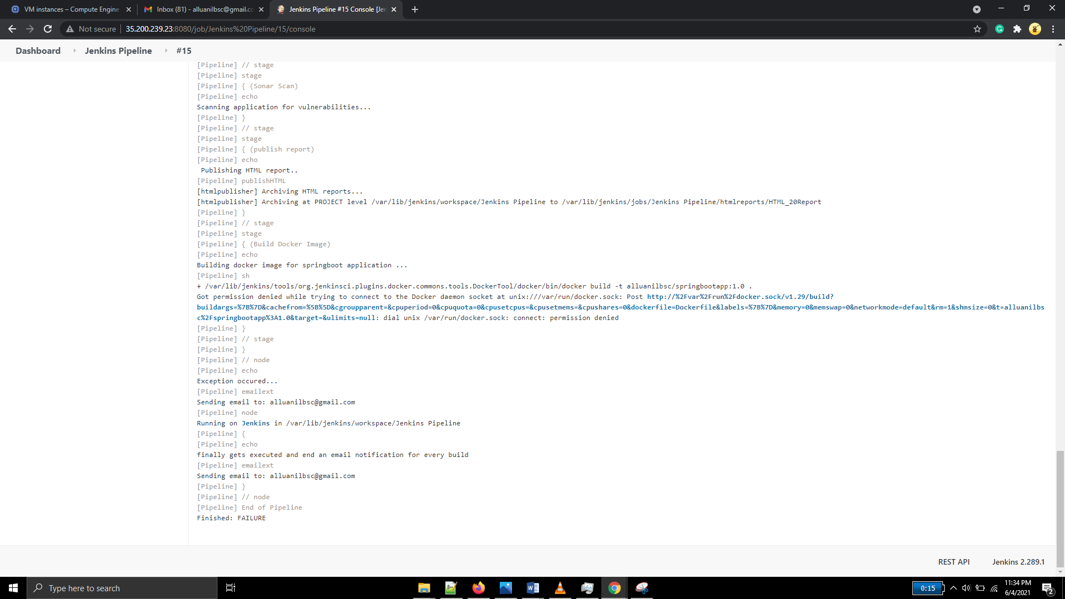

Executed the command “sudo usermod –a –G docker jenkins”, gave permissions and re ran the job

It failed again as pom.xml file not found

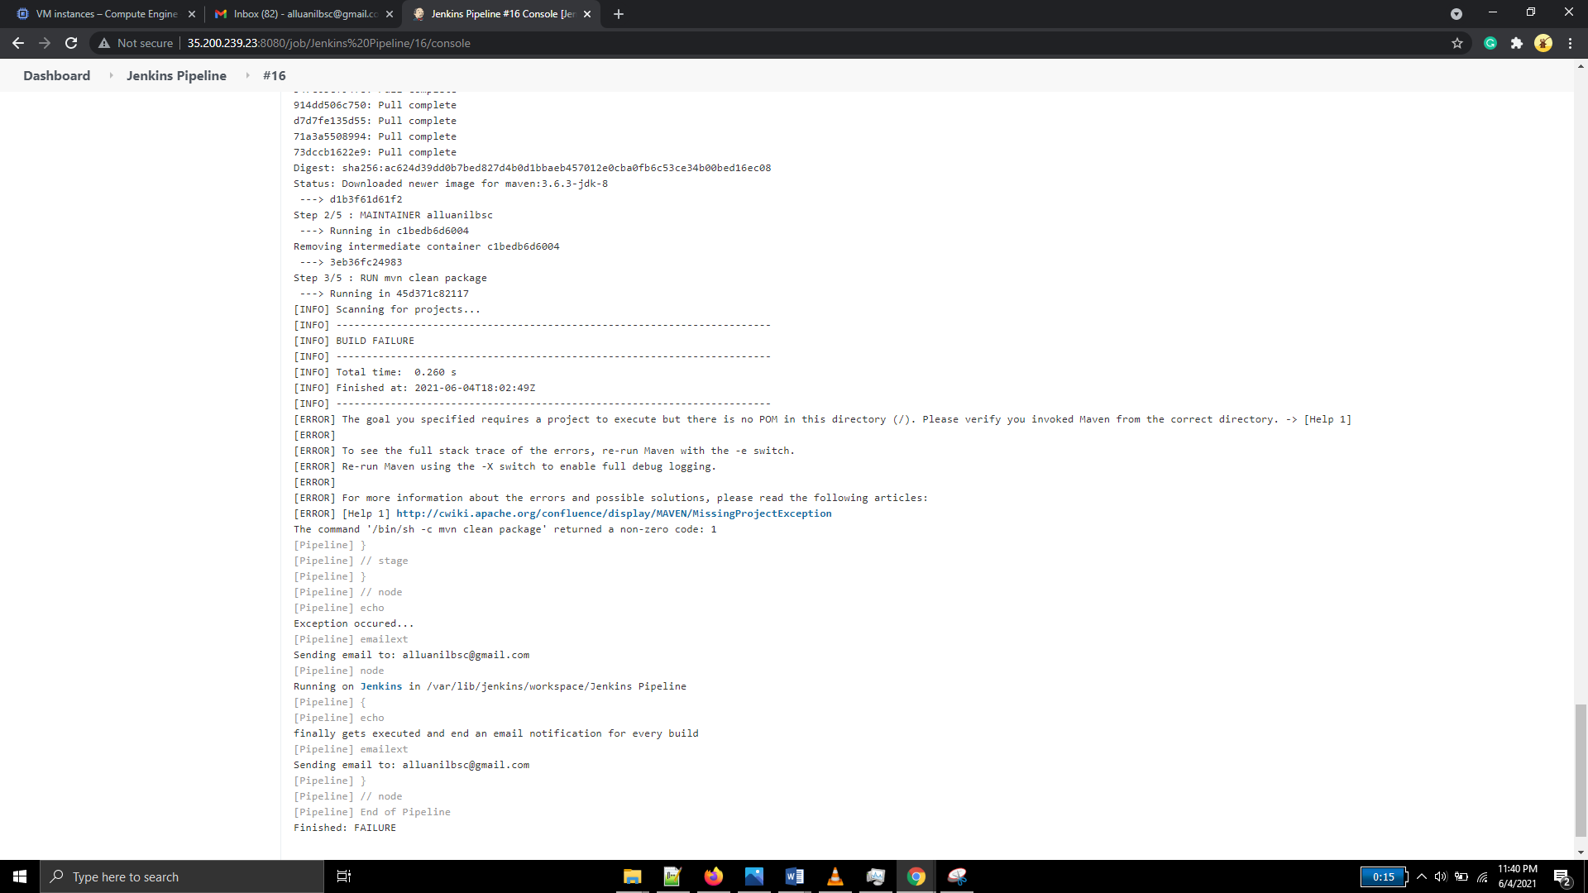

Modified the docker file to copy the pom.xml file and reran the job (build #17). It got completed

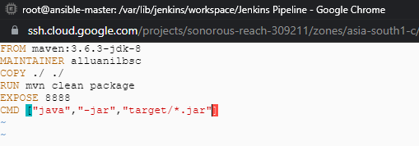

## Building of docker image using Jenkins runtime provided Docker

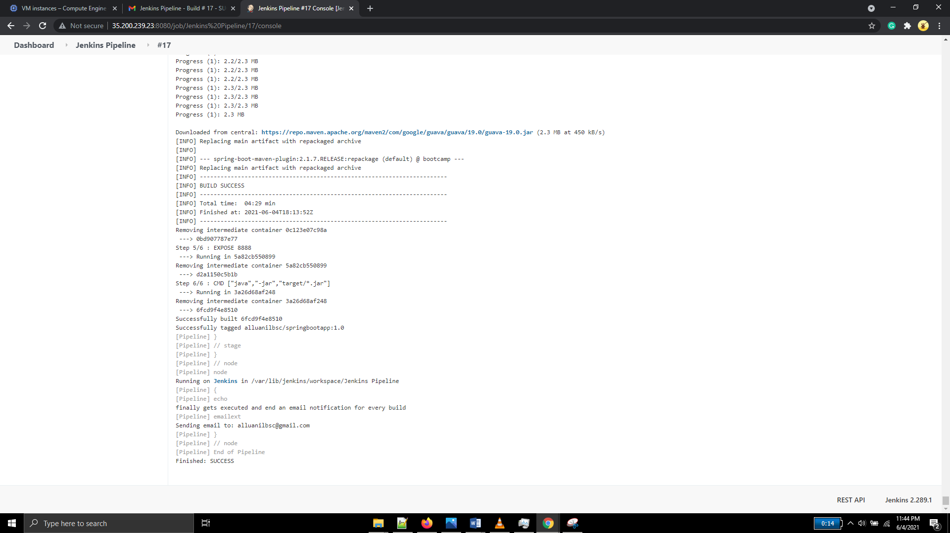

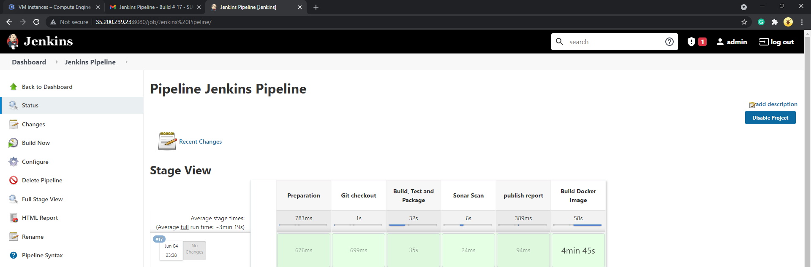

Docker image created

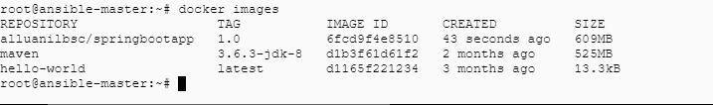

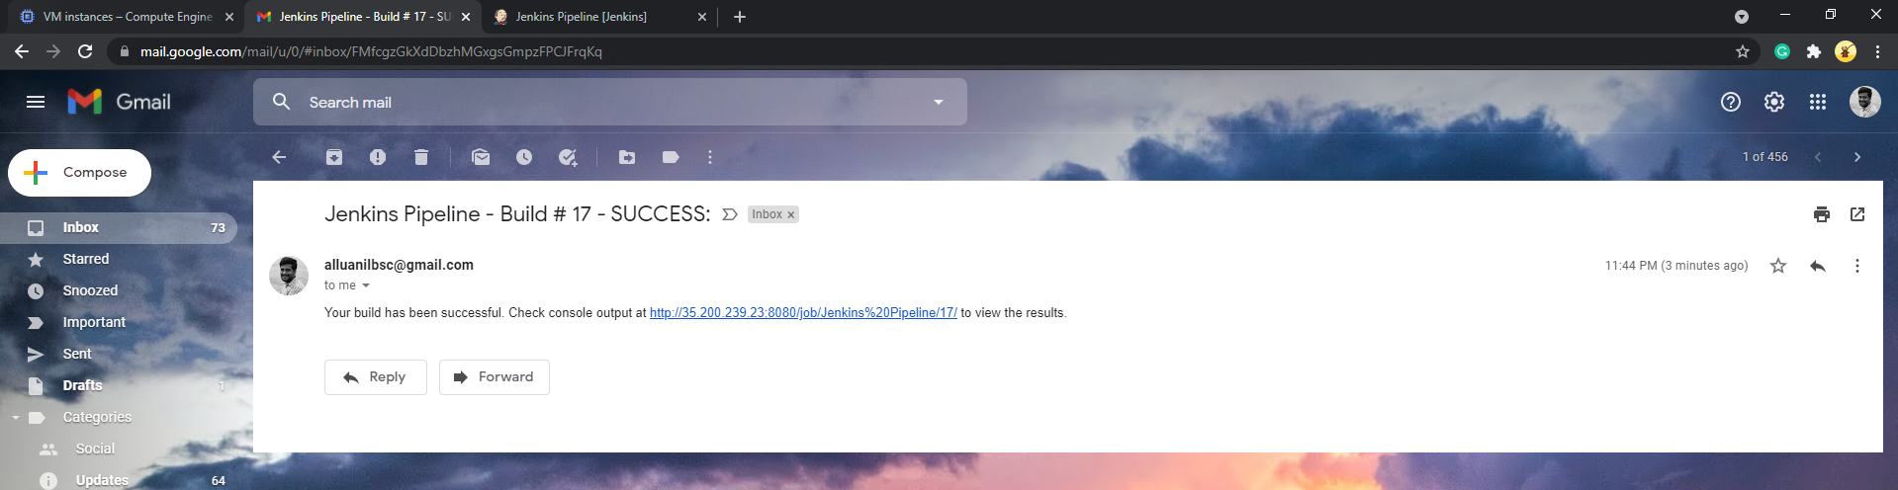

## Authentication to Docker Hub registry using With Credentials Plugin

Configured the password using with credentials plugin

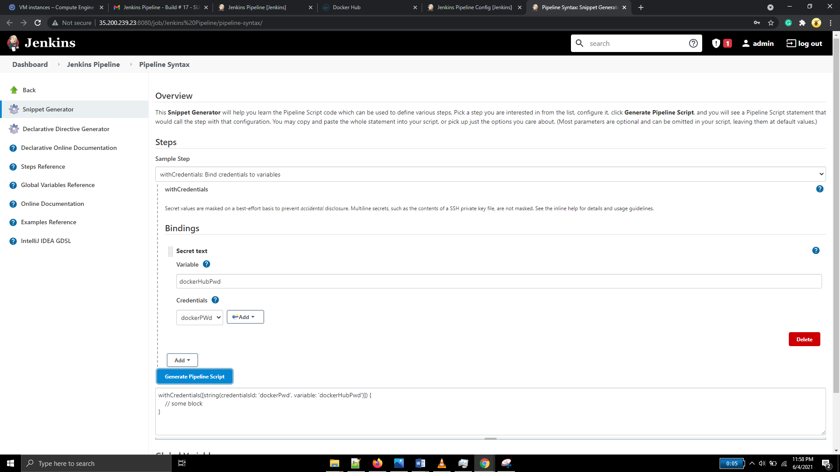

Pushing of Docker image using Jenkins runtime provided Docker

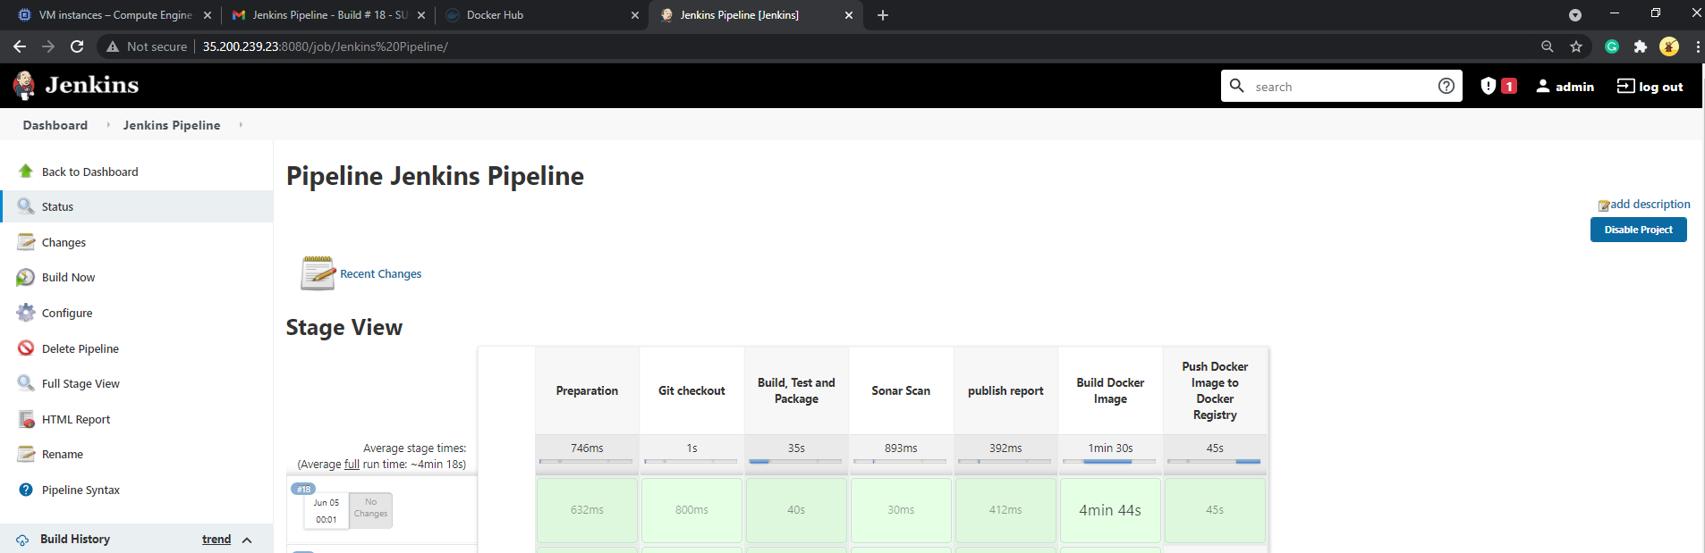

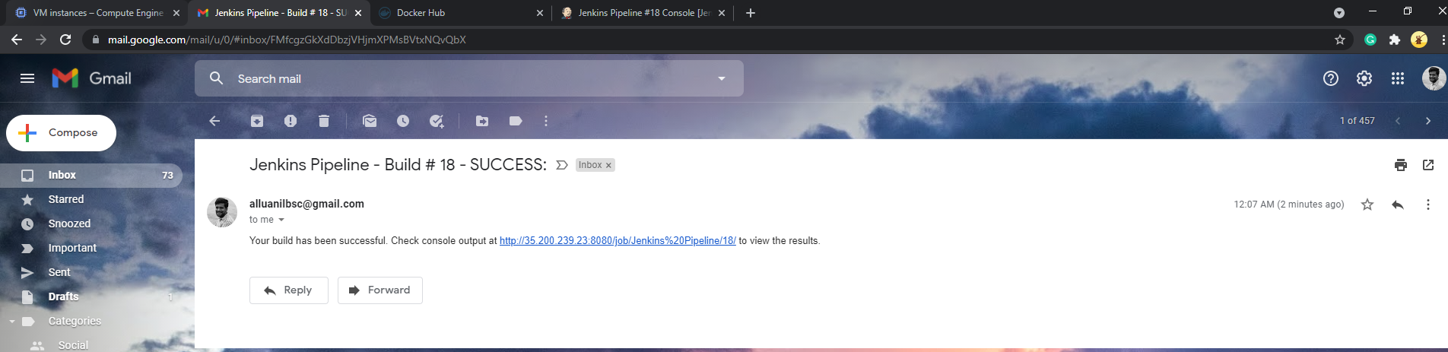

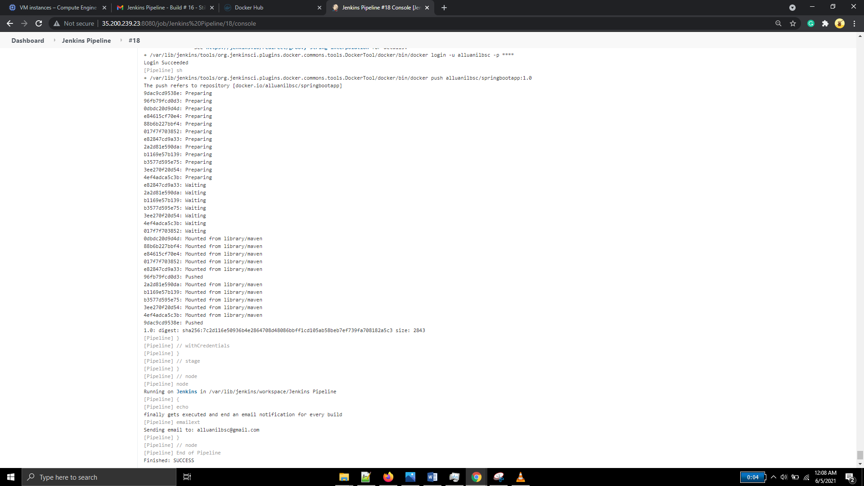

Image pushed to docker hub

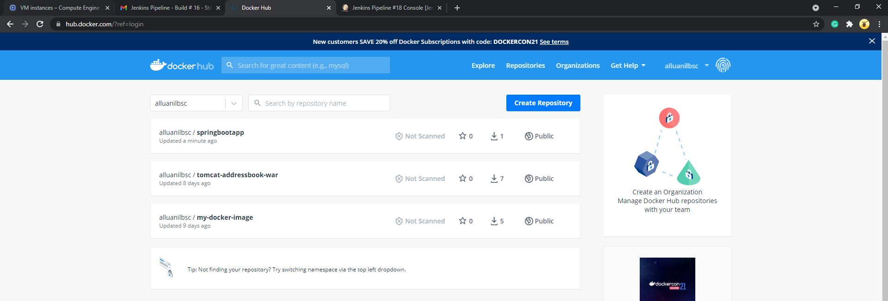

## Email alerts for Bad builds intimation

Build 16 got failed due to missing pom.xml file

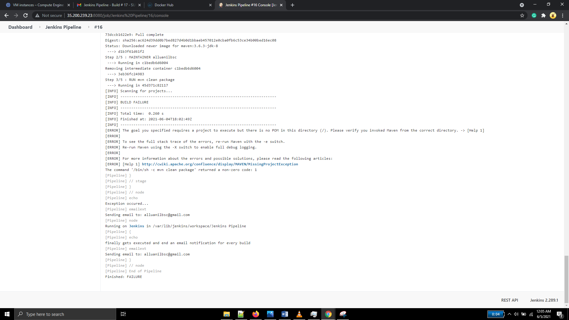

When the build fails, email notification is coming like below

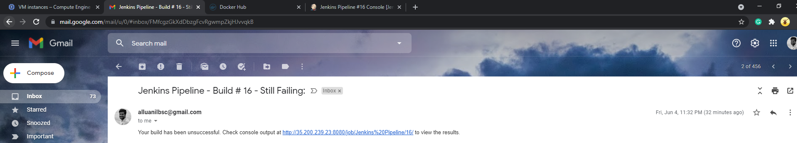

## Ansible plugin for automatic configuration of GCP Instance

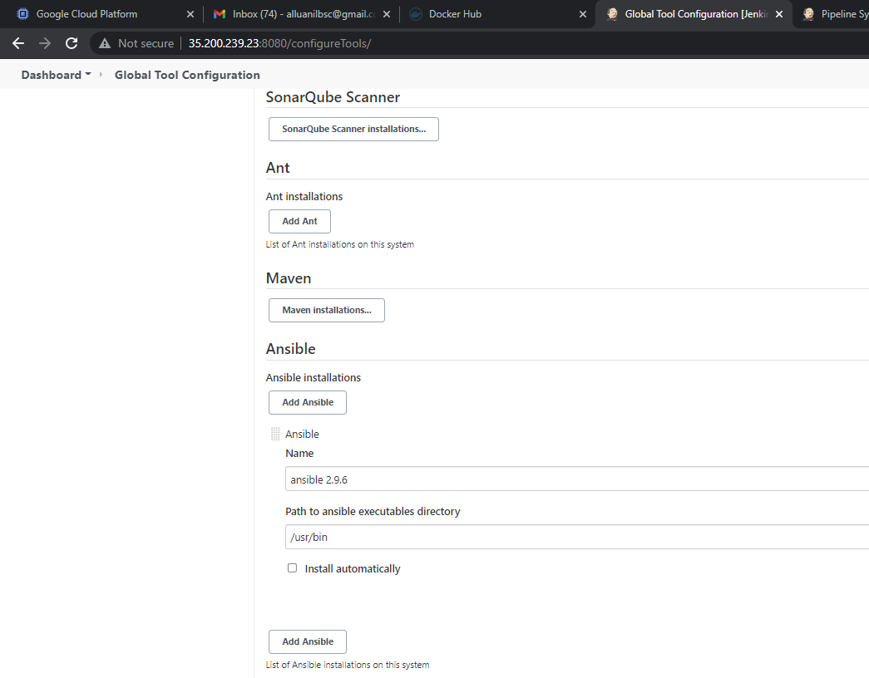

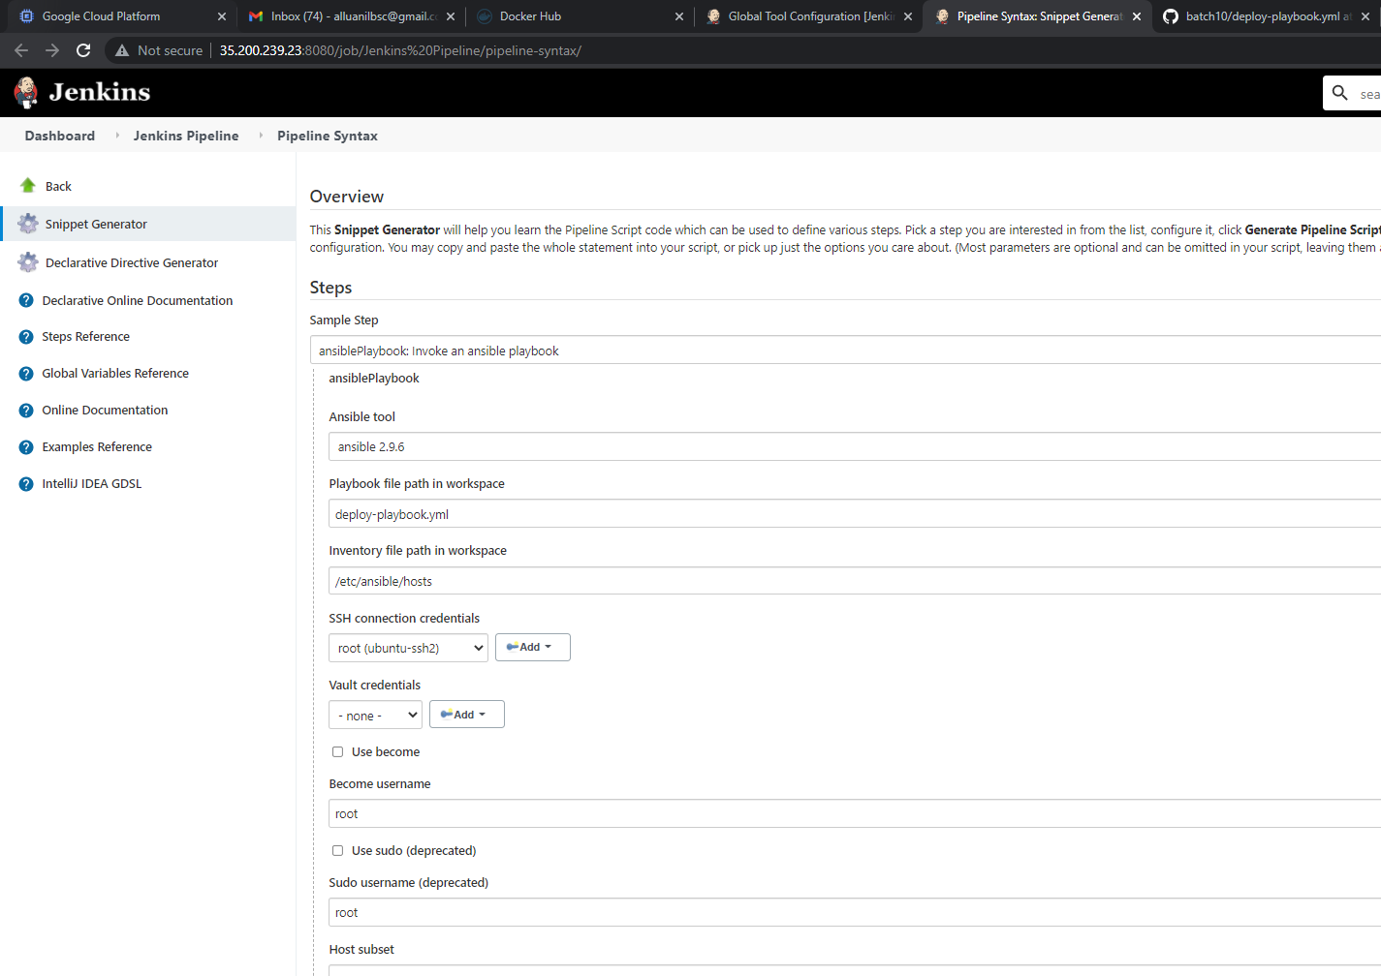

## Automatic deployment to GCP instance using Jenkins pipeline

Failed while deploying the docker image (build#21)

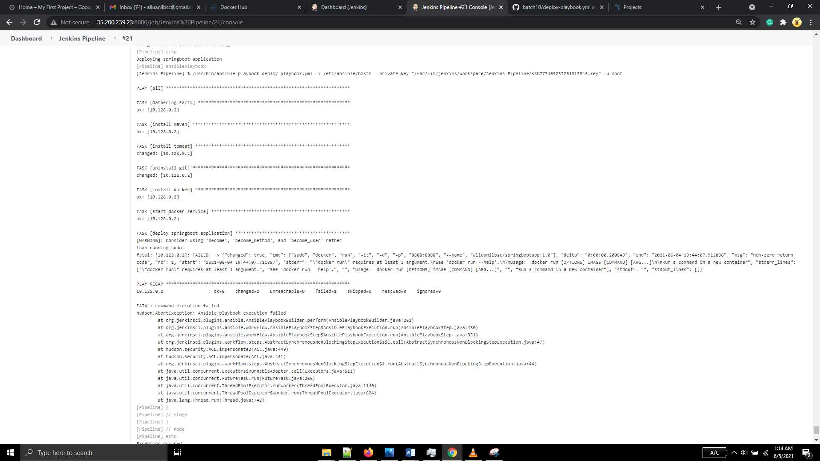

Corrected the docker run command in the playbook file and re-ran (along with configuring sonar). It ran successfully in build #26



Playbook log:

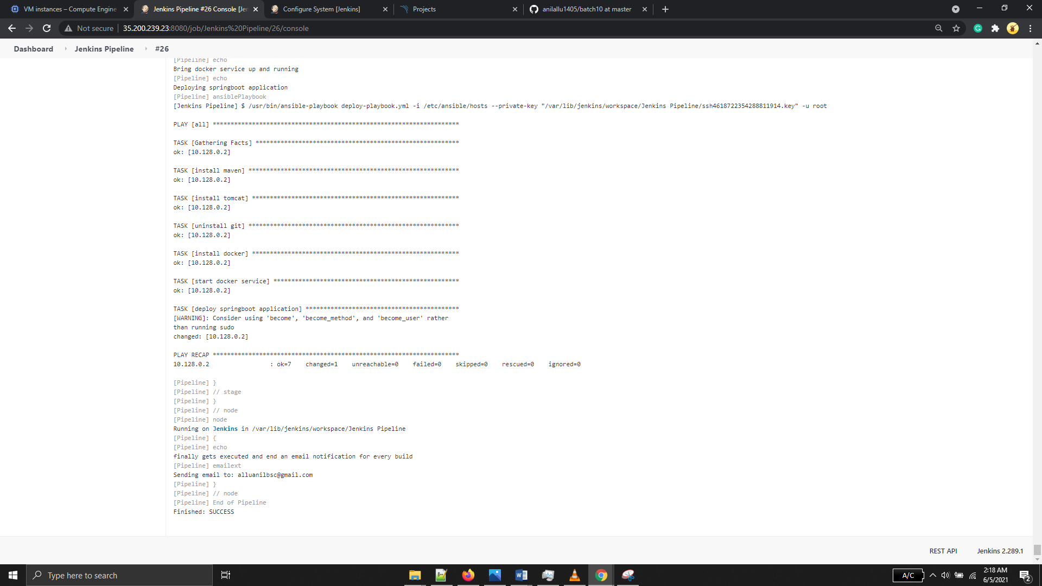

Image deployed in slave node

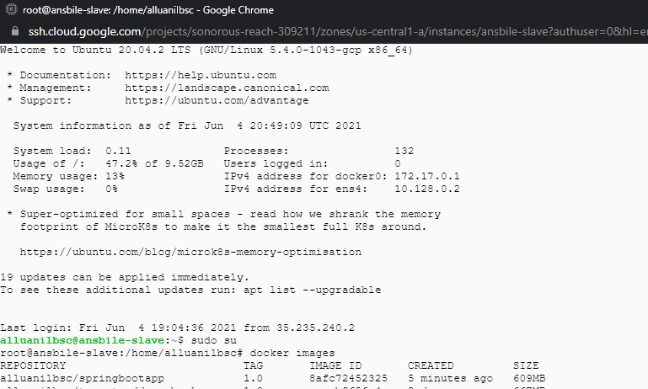

After deployment, the application page opened with 8888 port as below

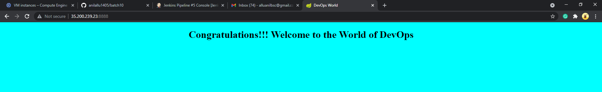

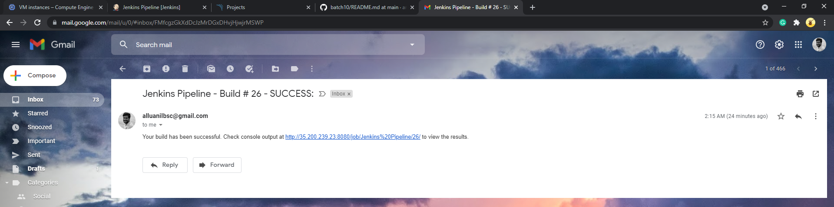

## GitHub webhook to trigger pipelines after every commit automatically

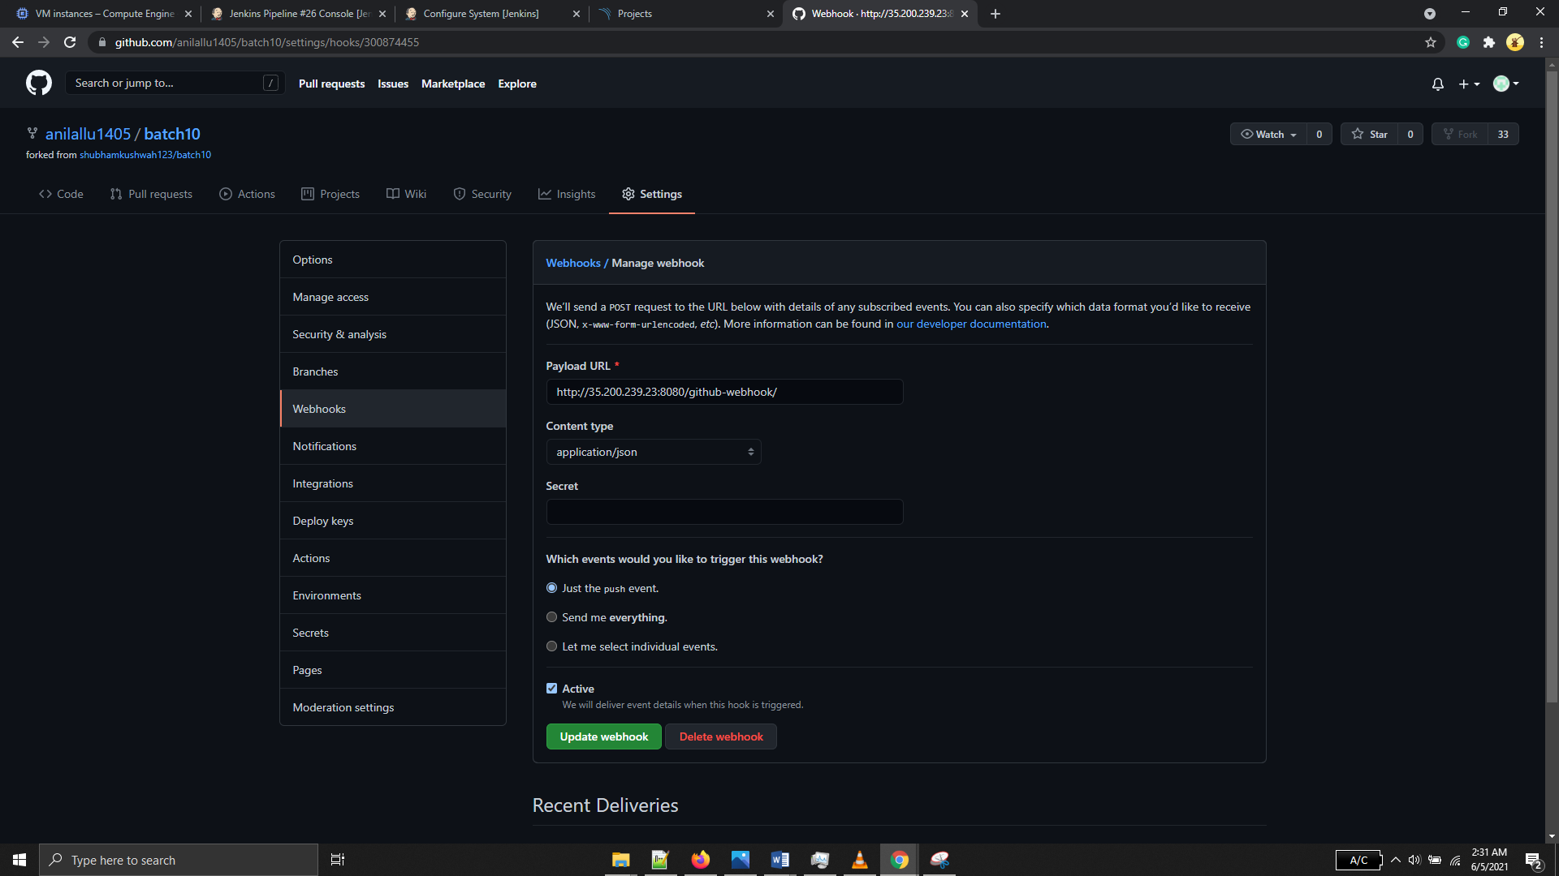

Created webhook for this project and edited git configuration in jenkins pipeline

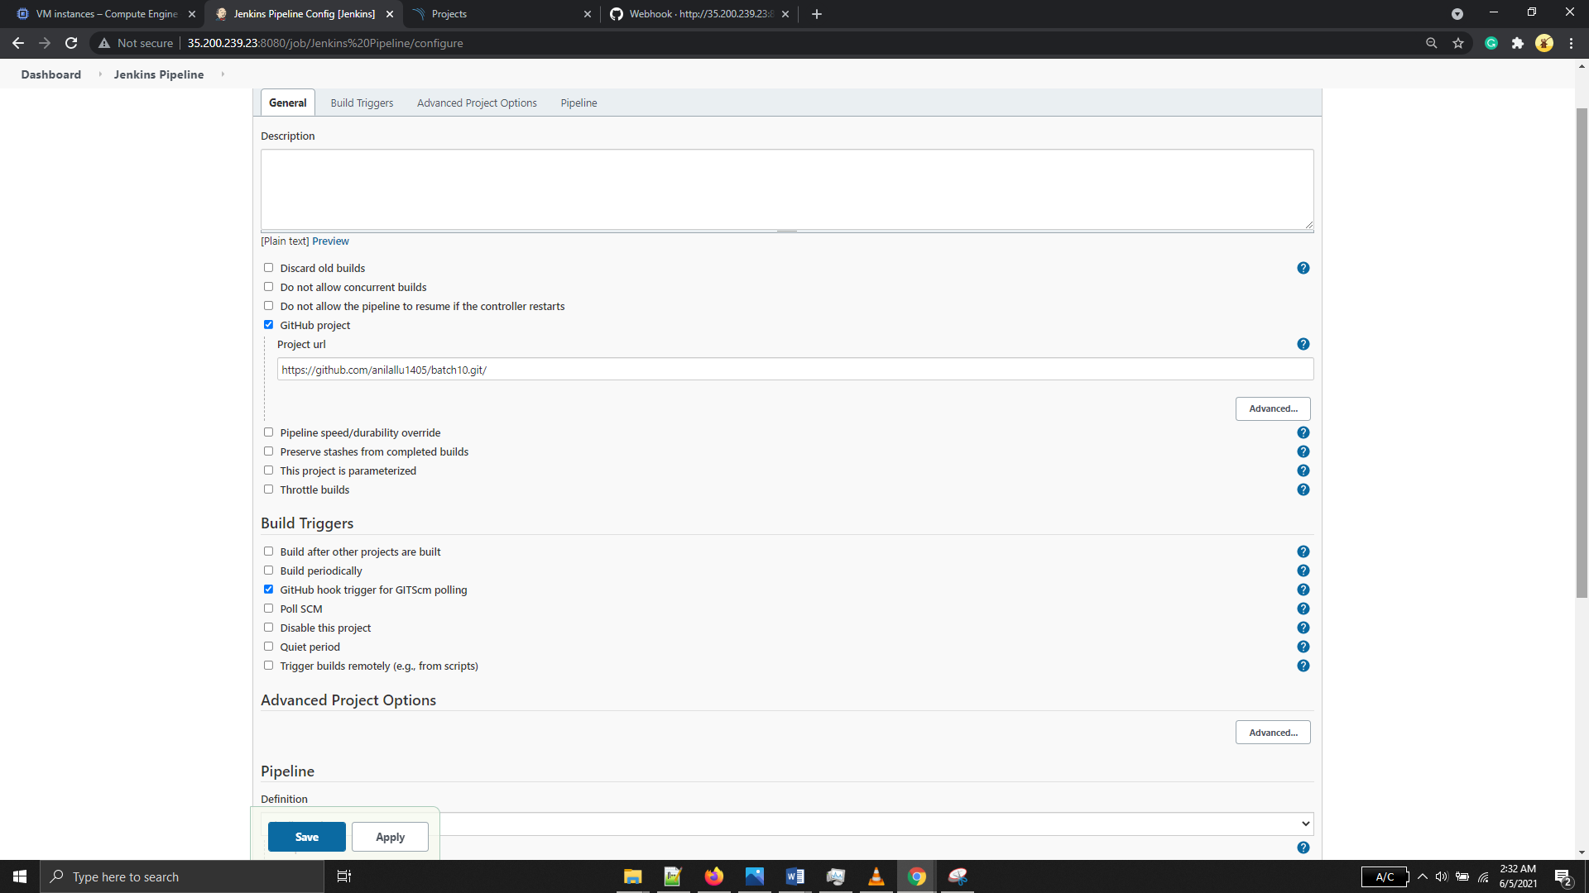

## Exception Handling and emails for every build

Emails getting triggered for each build with the build status

